|  |  |
| --- | --- |
| **ASSESMENT TEST** # **II**  **MAX MARKS : 100 TIME : 120 Minutes** | **Session Objectives**   * *Understand the basics of Inheritance* * *To understand the concept of Abstract classes & packages* * *To gain knowledge on Exception Handling* |
| **NAME: ____________________________** | **MARKS OBTAINED: ____ / 100 GRADE _____** |

**I. Fill in the Blanks (15 *2 = 30)**

1. An interface declaration can contain __________ and ___________________.
2. In OOP, a class can implement another class. This concept is referred to as ________________.
3. If a class does not declare that it extends another class, the parent of this class is ________________.
4. The _____________ keyword is used by a child class to explicitly access a field in the parent class or explicitly invoke a method in the parent class.
5. Super class ‘s ____________ can refer __________ class object and it is known as ___________
6. ____________ is the super class for all the exception classes in java.
7. ________ And ____________ are the two ways to create a Thread.
8. The mechanism in which a child class contains the same method as its parent class is call as _______________
9. A ______ class cannot be extended. A __________ method cannot be overridden.
10. By default all the variables in an interface are _______and__________.
11. In Java_________________ a library of classes.
12. Abstract class contains both _______________ & _________________.
13. To create a user defined exception a class must be a sub class of _____________class.
14. String objects are ____________ and StringBuffer objects are ____________.
15. The default thread priority in Java is____________

**II. What is the output of the following programs?** **(10* 3 =30)**

**Note** – *In case of Compilation error, please provide the reason too*.

|  |
| --- |
| **ANSWER BOX** |

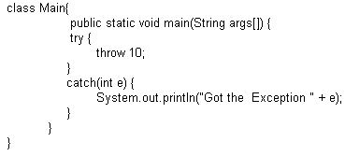**1)**

**2)**  class Test extends Exception { }

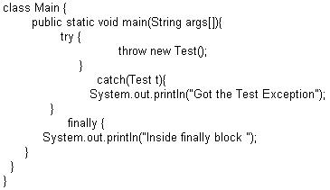

|  |
| --- |
| **ANSWER BOX** |

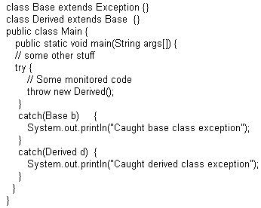**3)**

|  |
| --- |
| **ANSWER BOX** |

**4)** What is the Output of the Following? Explain?

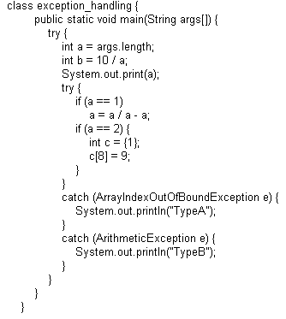

|  |
| --- |
| **ANSWER BOX** |

**5)** What is the output?

|  |
| --- |
| **ANSWER BOX** |

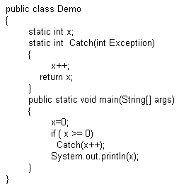

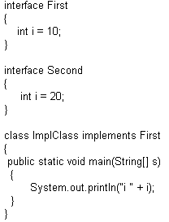**6)**

|  |
| --- |
| **ANSWER BOX** |

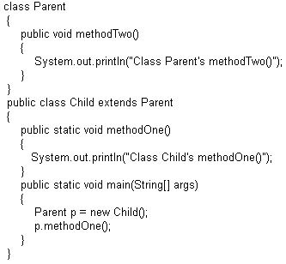**7)**

|  |
| --- |
| **ANSWER BOX** |

|  |
| --- |
| **ANSWER BOX** |

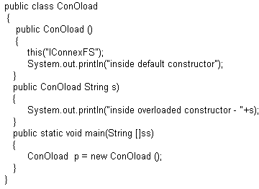**8)**

|  |
| --- |
| **ANSWER BOX** |

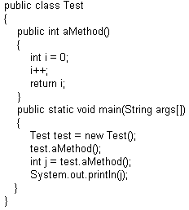**9)**

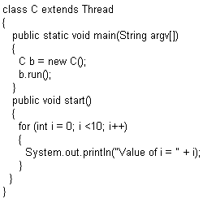**10)**

|  |
| --- |
| **ANSWER BOX** |

**III. Supply the required code for the following incomplete program (3*5 =15)**

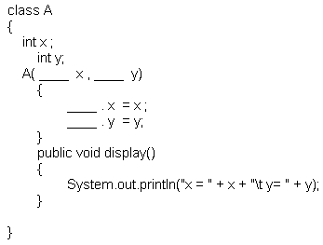

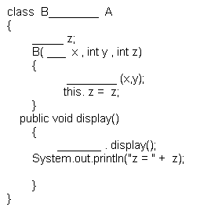

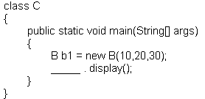

**2. Fill up the blanks by taking the code snippets from the Box given below.**

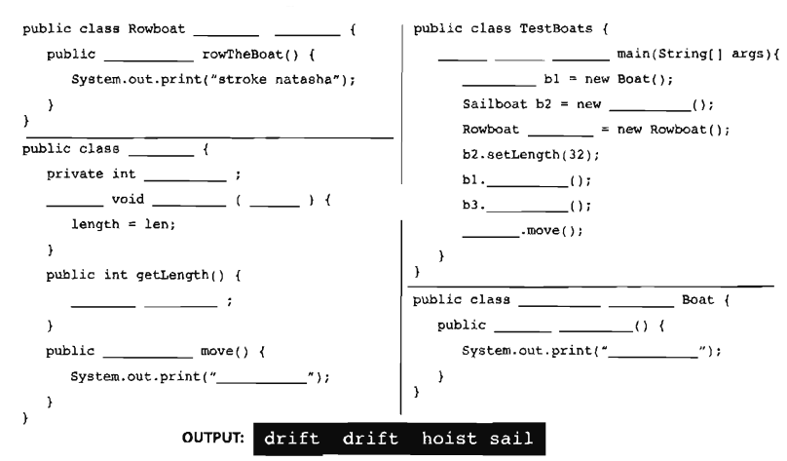

|  |
| --- |
|  |

3. Give the class declarations for the following diagrams.

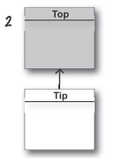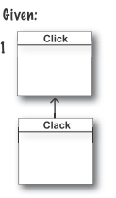

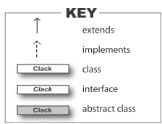

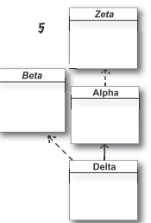

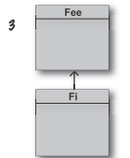

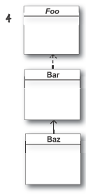

**IV. ANSWER THE FOLLOWING (10*2.5 = 25)**

**1) Given**

1. public class Electronic implements Device

{ public void doIt() { } }

2.

3. abstract class Phone1 extends Electronic { }

4.

5. abstract class Phone2 extends Electronic

{ public void doIt(int x) { } }

6.

7. class Phone3 extends Electronic implements Device

{ public void doStuff() { } }

8.

9. interface Device { public void doIt(); }

What is the result? (Choose all that apply.)

1. Compilation succeeds
2. Compilation fails with an error on line 1
3. Compilation fails with an error on line 3
4. Compilation fails with an error on line 5
5. Compilation fails with an error on line 7
6. Compilation fails with an error on line 9

**2) Given**

public abstract class Shape {

privateint x;

privateint y;

public abstract void draw();

public void setAnchor(int x, int y) {

this.x = x;

this.y = y;

}

}

Which two classes use the Shape class correctly? (Choose two.)

A. public class Circle implements Shape {

private int radius;

}

B. public abstract class Circle extends Shape {

private int radius;

}

C. public class Circle extends Shape {

private int radius;

public void draw();

}

D. public abstract class Circle implements Shape {

private int radius;

public void draw();

}

E. public class Circle extends Shape {

private int radius;

public void draw() {/* code here */}

}

F. public abstract class Circle implements Shape {

private int radius;

public void draw() { /* code here */ }

}

**3) Given**

10. classNav{

11. public enum Direction { NORTH, SOUTH, EAST, WEST }

12. }

13. public class Sprite{

14. // insert code here

15. }

Which code, inserted at line 14, allows the Sprite class to compile?

A. Direction d = NORTH;

B. Nav.Direction d = NORTH;

C. Direction d = Direction.NORTH;

D. Nav.Direction d = Nav.Direction.NORTH;

**4) Given two files**

1. package pkgA;

2. public class Foo {

3. int a = 5;

4. protected int b = 6;

5. public int c = 7;

6. }

3. package pkgB;

4. import pkgA.*;

5. public class Baz {

6. public static void main(String[] args) {

7. Foo f = new Foo();

8. System.out.print(" " + f.a);

9. System.out.print(" " + f.b);

10. System.out.println(" " + f.c);

11. }

12. }

What is the result? (Choose all that apply.)

A. 5 6 7

B. 5 followed by an exception

C. Compilation fails with an error on line 7

D. Compilation fails with an error on line 8

E. Compilation fails with an error on line 9

F. Compilation fails with an error on line 10

**5) What is the output**

1. package test;

2.

3. class Target {

4. public String name = "hello";

5. }

What can directly access and change the value of the variable name?

A. any class

B. only the Target class

C. any class in the test package

D. any class that extends Target

**6) Given:**

1. enum Animals {

2. DOG("woof"), CAT("meow"), FISH("burble");

3. String sound;

4. Animals(String s) { sound = s; }

5. }

6. class TestEnum {

7. static Animals a;

8. public static void main(String [] args) {

9. System.out.println(a.DOG.sound + " " + a.FISH.sound);

10. }

11. }

What is the result?

A. woof burble

B. Multiple compilation errors

C. Compilation fails due to an error on line 2

D. Compilation fails due to an error on line 3

E. Compilation fails due to an error on line 4

F. Compilation fails due to an error on line 9

**7) What is the Output.**

Given:

1. public class TestString1 {

2. public static void main(String[] args) {

3. String str = "420";

4. str += 42;

5. System.out.print(str);

6. }

7. }

What is the output?

A. 42

B. 420

C. 462

D. 42042

E. Compilation fails.

F. An exception is thrown at runtime.

**8) Given:**

3. public class TestDays {

4. public enum Days { MON, TUE, WED };

5. public static void main(String[] args) {

6. for(Days d : Days.values() )

7. { System.out.println(“”);}

8. Days [] d2 = Days.values();

9. System.out.println(d2[2]);

10. }

11. }

What is the result? (Choose all that apply.)

A. TUE

B. WED

C. The output is unpredictable

D. Compilation fails due to an error on line 4

E. Compilation fails due to an error on line 6

F. Compilation fails due to an error on line 8

G. Compilation fails due to an error on line 9

**9) Given**

class Plane {

static String s = "-";

public static void main(String[] args) {

new Plane().s1();

System.out.println(s);

}

void s1() {

try { s2(); }

catch (Exception e) { s += "c"; }

}

void s2() throws Exception {

s3(); s += "2";

s3(); s += "2b";

}

void s3() throws Exception {

throw new Exception();

} }

What is the result?

A. -

B. -c

C. -c2

D. -2c

E. -c22b

F. -2c2b

G. -2c2bc

H. Compilation fails

**10) Given:**

3. class SubException extends Exception { }

4. class SubSubException extends SubException { }

5.

6. public class CC { void doStuff() throws SubException { } }

7.

8. class CC2 extends CC { void doStuff() throws SubSubException { } }

9.

10. class CC3 extends CC { void doStuff() throws Exception { } }

11.

12. class CC4 extends CC { void doStuff(int x) throws Exception { } }

13.

14. class CC5 extends CC { void doStuff() { } }

What is the result? (Choose all that apply.)

A. Compilation succeeds

B. Compilation fails due to an error on line 8

C. Compilation fails due to an error on line 10

D. Compilation fails due to an error on line 12

E. Compilation fails due to an error on line 14